DEPARTMENT OF NATURAL SCIENCES
LESSON PLAN
NAME OF TEACHER: ……………………… DATE:
SUBJECT: Mathematics DURATION:80 MINUTES
TOPIC: Identify and create loops in flow charts CLASS:
SUBTOPIC: Loops NO OF BOYS…
GIRLS…
REFERENCES: Excell and advance iin mathematics book 9 and progress in mathematics book 9
TEACHING LEARNING /AIDS: learners book, chalk board and chart
RATIONALE: This lesson is on looping, Teacher exposition discussion and question and answer methods will be used. This lesson will develop learners knowledge about Basic programming ( Writing simple computer programmes).The skill of Application of flow charts to real life.The value of Logical thinking in constructing flow charts.
LEARNING OUTCOMES: L.S.B.A.T:
- Identify and create loops in flow charts
PREREQUISITE KNOWLEDGE: Learners have ideas about the topic being taught.
LESSON INTRODUCTION: Brainstorming questions about the topic being taught will be used to introduce the topic and to revise through the previous lesson
LESSON DEVELOPMENT
CONTENT | TEACHER’S ACTIVITY | PUPIL’S ACTIVITY | METHODS
REPETATION (LOOPING) IN A PROGRAM  -some programs involves repeating a task until a certain condition is met.This is known as looping or iteration  -The three main looping control are  - The WHILE loop  - The REAPET……UNTIL loop  - The FOR loop  THE WHILE LOOP  In general the while loop can be represented using a pseudocode and a flowchart a shown below  Pseudocode segment  WHILE <condition>DO  Statements  ENDWHILE  FLOWCHART EXTRACT  Statement  condition  The ‘WHILE’ loop is used if a condition has to be met before the statement within the loop are executed .Therefore ,this type of loop allows the statement to be executed zero or many time  EXAMPLE  In banking ,to withdraw money using an automated teller machine (ATM),a customer must have a balance in his/her account  SOLUTION  Pseudocode  WHILE segment >0DO  With draw cash  Update cash  ENDWHILE  Flowchart extract  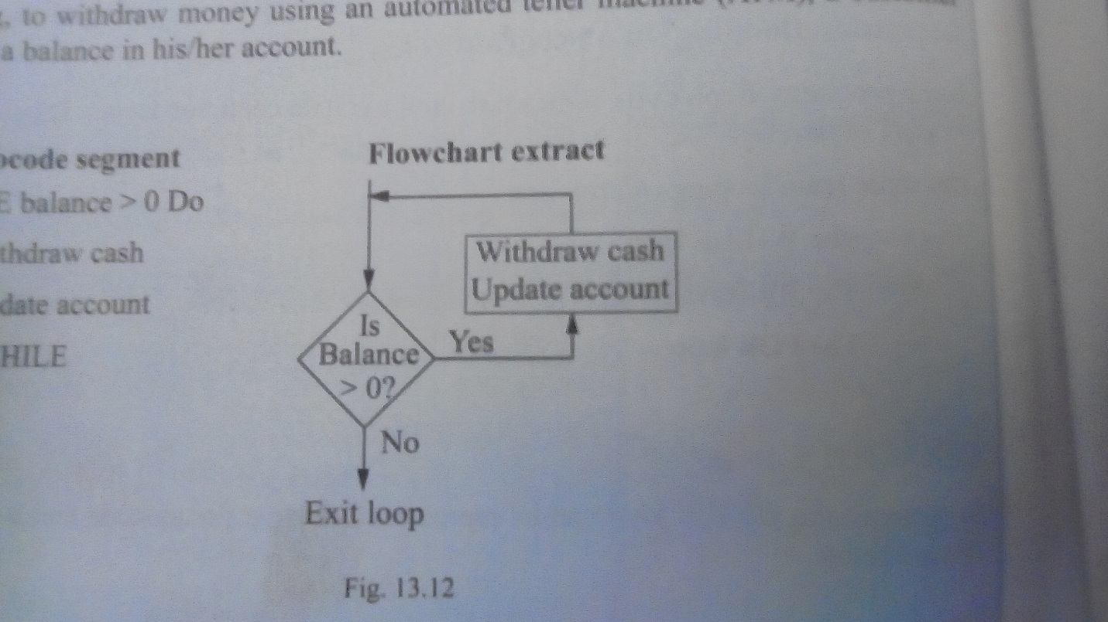  The REPEAT……..UNTIL loop  The general format of the REPEAT……….UNTIL loop is ;  Pseudocode  REPEAT  Statement  UNTIL<condition>  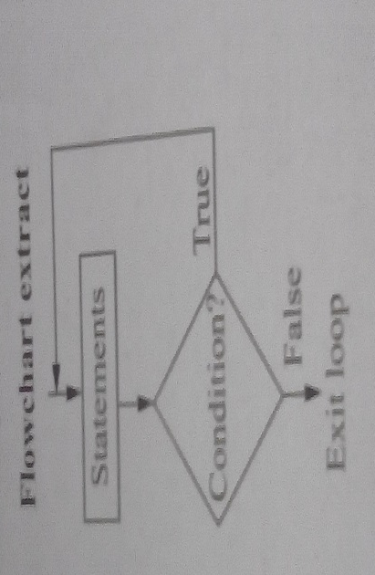  Unlike the ‘while’ loop,repeat ……until allows the statement within it to be executed at least once the condition is tested at the end of the loop  EXAMPLE  Consider the ATM each withdraw case discussed under the ‘WHILE’ loop. If the respect ……INTIL is used ,then the client will be able to withdraw the cash at least once since availability of balance is tested at the end of the loop as shown below.  Pseudocode  REPEAT  Withdraw cash  Update account  UNTIL balance 0;  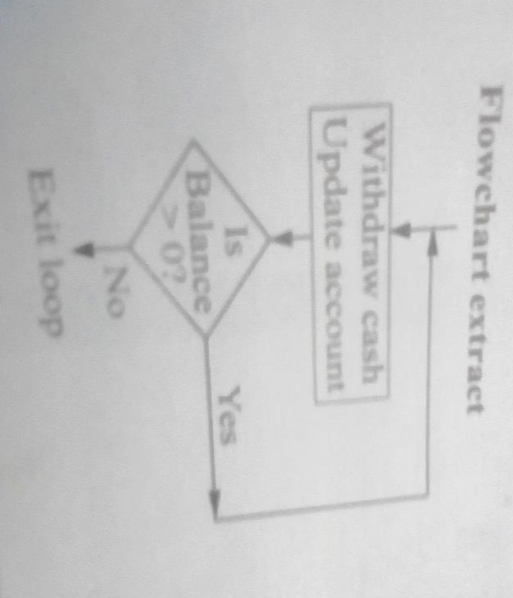  EXERCISE  Wreite a flow chart for the following algorithm to show how to use a decision loop  - Start  - Let the sum be 0  - Find the value  - If the value equals -1,go to step 7  - Let sum=sum+value  - Go to step 3 to find the next value  - Divide sum by 1500  - Output the average  - stop | Teacher to explain the three main looping control  Teacher to write the example on the board  Teacher to solve on the board and allows learners to ask questions  Teacher to explain about the repeat …..until loop  And writes the example on the board  Teacher to solve on the board and allows learners to ask questions  Teacher to write the exercise on the board | Learners listen attentively and ask questions  Learners to write the example in their exercise book  Learners listens attentively and ask questions  Learners listens attentively and ask questions  Learners listens attentively and ask questions  Learners to write the exercise in their exercise books  EXPECTED ANSWER  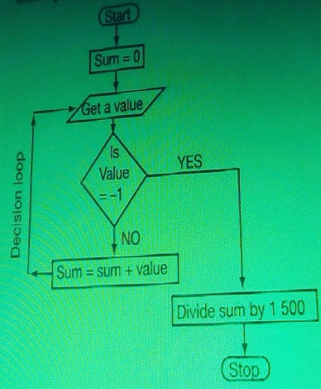
Lesson conclusion: Tr to conclude lesson by revising through the lesson with leaners to help remedial learners
Learners evaluation: ………………………………………………………………………………………………………………………………………………………………………………………………………………………………………………………………………………………………………………………………………………………………………………………………………………………………………………………………………………………………………….…………
Teachers evaluation:

